

**Submitted to:**

**Submitted by: Roll no:**

**Engr. Waqas Saleem Hadia Zakir**

**Section:**

**2023-BSE-019**

**5B**

Cloud Computing Assignment # O1

* **Screenshot of my Gitea repository (showing README listing name & roll number)**

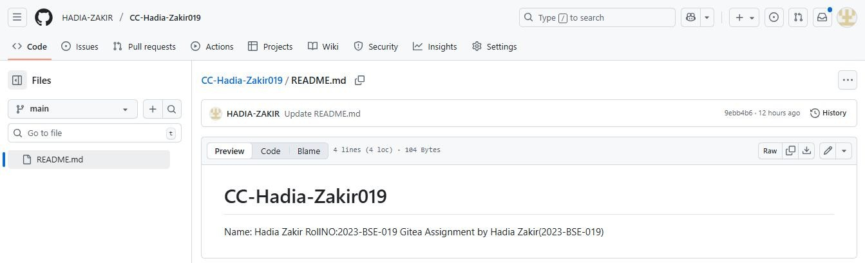

* **GitHub assignment 1 repo link (with README and large files)**

git@github.com:HADIA-ZAKIR/Assignment-1.git

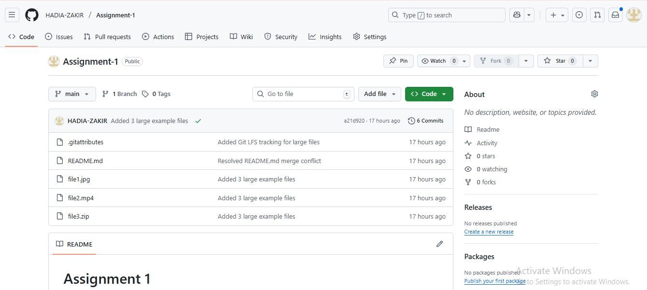

* **Screenshot or output of git remote -v showing both remotes**

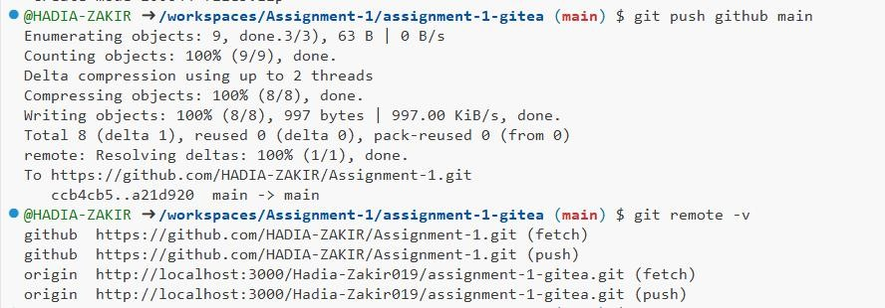

* **GitHub Pages link to your CV/portfolio**

<https://hadia-zakir.github.io/>